MEETING OF MAYOR AND COUNCIL
WEDNESDAY, APRIL 28, 2010 - 7:00 P.M.

* MEETING CALLED TO ORDER * STATEMENT REGARDING *OPEN
PUBLIC MEETING LAW * SALUTE TO THE FLAG
The meeting was called to order by Mayor Martin at 7:05 p.m. Adequate notice of this meeting
was provided as is required by the Open Public Meetings Law with advertising in the Home News Tribune and posting on the bulletin board. All present Pledged Allegiance to the Flag.

* CALLING OF THE ROLL:
Clmn. Peckham– Present
Asciolla - Present
Janeczek – Present
Karczewski – Absent
Perez – Present
Smith - Absent

* PUBLIC PORTION
Robert Maglies presented a calendar he received from Lavalette and thinks it would be good if the Borough of Helmetta had such a calendar printed.
He complemented the Borough Attorney David Clark on the letter he wrote to the A.B.C.

* INTRODUCTION OF BUDGET
The Budget was introduced. Clmn. Peckham, Asciolla, Janeczek and Perez were in favor of the introduced budget. The budget will be advertised in the May 13, 2010 edition of the Home News Tribune and a Public Hearing will be held on May 26, 2010.

* MUNICIPAL CONSENT HEARING ON CABLE RENEWAL
The legal ad published was 3/11/10 and 4/17/10 for this hearing.
Robert Clifton, Director of Affairs for Comcast gave a brief presentation on Comcast.
The hearing was opened to the Public. There being no one from the Public who
wished to speak, the hearing was closed to the Public.

* CONSENT AGENDA – RESOLUTION # 2010 - 107
Reports of Tax Collector, Utility Revenue Collector
RESOLUTIONS:
96 – Senior Citizen Deduction
97 – Grant for Volunteer Fire Assistance
98 – Stipend for Cindy Shapter
99 – Payment to East Brunswick for improvement of water system
100 – Grant agreement with the County for improvements to Helmetta Lake Park
101 – Authorization for Michael Testa to prepare architectural design of Parcel 5
102 – Reimbursement to Regency Walk
103 – Reimbursement to Heather Glen Condominium Association
104 - Payment of Bills
105 – Refund checks for Landlord Registrations
106 – Bingo License
107 – Final payment to Mario’s Concrete & Paving Co., Inc. (pulled from consent agenda)
109 – Authorization to apply for Tonnage Grant
Application for Helmetta Fire Department – Peter A. Tresch (pulled from consent agenda)

MARCH, 2009 |  |  |  |  |  | MUNICIPAL CLERK REPORT
 |  |  |  | Copies |  | Marriage License |  |  | Recycling |  |  | Towing | Lndlrd Reg |  | Plng Bd | Licenses
Brennan |  |  |  | $10.00
 |  |  |  | $10.00
Capran |  |  |  |  |  |  |  |  |  |  |  |  |  |  | $10.00
Ice cream truck |  |  |  |  |  |  |  |  |  |  |  |  |  |  |  | $60.00
CJS |  |  |  | $15.00
Ciccariello |  |  |  | $10.00
Ali |  |  |  |  |  |  |  |  |  |  |  |  | $100.00
Carver |  |  |  |  |  |  |  |  |  |  |  |  | $200.00
Kendall |  |  |  |  |  |  |  |  |  |  |  |  | $200.00
Williams |  |  |  |  |  |  |  |  |  |  |  |  | $200.00
 |  |  |  |  |  |  |  |  |  |  |  |  | $100.00
Buchan |  |  |  | _______ |  |  |  |  |  |  |  |  | $200.00
T0TAL $1,115,00 |  |  |  | $45.00 |  |  |  |  |  |  |  |  | $1,000.00 |  | $10.00 | $60.00
Dog and Cat Licenses |  |  |  |  |  | $930.00
 |  |  |  |  |  |  |  |  |  |  | Denise Jawidzik
 |  |  |  |  |  |  |  |  |  |  | Denise Jawidzik
REPORT OF THE TAX COLLECTOR |  |  |  |  |  |  |  |  |  |  | Tax Collector
Month of: | March, 2010
Dated: | April 5, 2010
Taxes - 2009 |  |  |  |  |  |  | $ 8,951.31
Taxes - 2010 |  |  |  |  |  |  | $ 42,721.46 |  |  |  | ADJUSTMENTS
 |  |  |  |  |  |  |  |  |  |  | 2010 | Disallow deduction |  | $ 1,500.00
Interest |  |  |  |  |  |  | $ 1,934.97
Costs
Tax search
Return Check fee
Search Printouts
Duplicate Bill Fee |  |  |  |  |  |  | $ 10.00
Misc. |  |  |  |  |  |  |  |  |  |  | Closing Balances
 |  |  |  |  |  |  |  |  |  |  |  | Debit |  | Credit |  |  | Net
 |  |  |  |  |  |  |  |  |  |  | Tax 2009 | $ 70,840.12 |  | $ (2.20) |  |  | $ 70,837.92
 |  |  |  |  |  |  |  |  |  |  | Tax 2010 | $ 1,266,188.54 |  | $ (258.10) |  |  | $1,265,930.44
 |  |  |  |  |  |  |  |  |  |  |  |  |  | $ -
TOTAL |  |  |  |  |  |  | $ 53,617.74

Water/Sewer Receipts Report
March 2010
 | Water |  | Sewer |  | Total
2007 Principal | $ - |  | $ - |  | $ -
2008 Principal | 164.87 |  | 379.79 |  | 544.66
2009 Principal | 3,675.13 |  | 4,266.85 |  | 7,941.98
2010 Principal | 7,863.30 |  | 8,405.58 |  | 16,268.88
Subtotal | 11,703.30 |  | 13,052.22 |  | 24,755.52
Interest | 220.57 |  | 222.64 |  | 443.21
Subtotal | 11,923.87 |  | 13,274.86 |  | 25,198.73
Final Water Reads | 20.00 |  | - |  | 20.00
Returned Checks | - |  | - |  | -
Payment Reversal | - |  | - |  | -
NSF Bank Fees | - |  | - |  | -
Connection Fee | - |  | - |  | -
Water Turn-on Fee | - |  | - |  | -
Transfer in from Tax | - |  | - |  | -
Transfer out | - |  | - |  | -
Total Deposits | $11,943.87 |  | $ 13,274.86 |  | $ 25,218.73
Carol Feig
Utility Collector

RESOLUTION
2010 – 96

RESOLUTION AUTHORIZING THE TAX COLLECTOR
TO ISSUE A SENIOR CITIZENS DEDUCTION FOR
15 BORGHAUS ROAD AND IDENTIFIED ON THE BOROUGH TAX MAP AS BLOCK 21 LOT 13

WHEREAS, the Borough Tax Collector has received an application for a Senior Citizens Deduction in the amount of $250.00 for 2010 taxes on property located at 15 Borghaus Road and identified on the Borough’s tax map as Block 21 Lot 13, (the Property); and

WHEREAS, the Borough Tax Collector requests authorization from the Borough Council to issue such a deduction to the owner of the Property.

NOW, THEREFORE, BE IT RESOLVED by the Borough Council of the Borough of Helmetta that the Borough Tax Collector is hereby authorized to make such an adjustment for a Senior Citizens Deduction to the Property’s owner; and

BE IT FURTHER RESOLVED that the Borough’s Tax Collector is directed to make an adjustment in the amount of $250.00 to the Property’s owner, Stanley Spack, 15 Borghaus Road, Helmetta, NJ 08828.

RESOLUTION
2010 – 97

AUTHORIZATION FOR CFO TO APPLY FOR A
GRANT FOR VOLUNTEER FIRE ASSISTANCE

WHEREAS, the Governing Body of the Borough of Helmetta desires to further the public interest by obtaining a grant from the State of New Jersey for Volunteer Fire Assistance ;

NOW THEREFORE BE IT RESOLVED, that Lori Russo is hereby authorized to make application and if awarded to execute a grant agreement with the State.

RESOLUTION
# 2010 - 98
STIPEND FOR CINDY SHAPTER ON COURT NIGHTS

BE IT RESOLVED, by the Mayor and Council of the Borough of Helmetta that Cindy Shapter is hereby to receive a $75.00 stipend for her work on Court nights.

RESOLUTION
# 2010 – 99

RESOLUTION AUTHORIZING PAYMENT TO EAST
BRUNSWICK FOR UPGRADED VALVES

WHEREAS, the Borough of Helmetta entered into an agreement with the Township of East Brunswick to construct and install improvements to its water system including installation of new valves and a SCADA system to benefit Helmetta; and

WHEREAS, Darren Doran, Water Operator, felt it would be in the best interest of the Borough of Helmetta to have these valves upgraded; and

WHEREAS, Resolution #09-171 authorized payment not to exceed $45,000.00; and the upgrades brought the cost up to $45,882.64 ;

NOW THEREFORE BE IT RESOLVED, by the Borough Council of the Borough of Helmetta that the CFO is hereby authorized to make additional payment to the Township of East Brunswick in the amount of $882.64;

BE IT FURTHER RESOLVED, that the Chief Financial Officer has executed a Certification of Funds for final payment of this contract, which is attached hereto, and that sufficient funds are available for said contract from Account Number C-06-55-450-110.

BE IT FURTHER RESOLVED that the Borough Clerk is hereby directed to provide a certified copy of this Resolution to each of the following:

- Richard Brand, Township of East Brunswick
- David A. Clark, Esq.
- Darren Doran, Director of Public Works
- Lori Russo, CFO

RESOLUTION
# 2010 – 100

RESOLUTION OF THE BOROUGH OF HELMETTA AUTHORIZING A GRANT AGREEMENT WITH THE COUNTY FOR IMPROVEMENTS TO HELMETTA LAKE PARK

WHEREAS, the County of Middlesex (the “County”) has established an “Open Space, Recreation and Farmland and Historic Preservation Trust Fund” (the “Fund”) through which it distributes monies deposited therein to municipalities within the County to be used for purposes for which the Fund was established; and

WHEREAS, the Borough of Helmetta (the “Borough”) has submitted a proposal to the County in connection with the Fund for improvements to Helmetta Lake Park which include construction of a picnic pavilion which will include space for a concession/bathroom/shelter (the “Improvements”); and

WHEREAS, the County has evaluated the proposal and has authorized a grant agreement with the Borough in the amount of $250,000.00 for the Improvements.

NOW, THEREFORE, BE IT RESOLVED by Borough Council of the Borough of Helmetta that the Mayor is hereby authorized to sign all documents necessary to execute a grant agreement with Middlesex County in the amount of $250,000.00 for the construction of a picnic pavilion, which will include space for a concession/bathroom/shelter at the Helmetta Lake Park.

BE IT FURTHER RESOLVED, that a certified copy of this Resolution shall be provided to each of the following:

a. Margaret E. Pemberton, Clerk, Middlesex County
b. Lori Russo, Borough Chief Financial Officer

RESOLUTION
# 2010 – 101

RESOLUTION OF THE BOROUGH OF HELMETTA AUTHORIZING MICHAEL TESTA, A.I.A. TO PREPARE AN ARCHITECTURAL DESIGN STUDY ON PARCEL 5 OF THE HELME MILL REDEVELOPMENT AREA IN AN AMOUNT NOT TO EXCEED $7,500.00

WHEREAS, the Borough of Helmetta (the “Borough”) wants to undertake an architectural design study in order to explore the potential use of parcel 5 of the Helme Mill Redevelopment Area as an animal shelter; and

WHEREAS, the Borough Council would like to authorize Michael Testa, A.I.A., a licensed architect, to perform such architectural design study on parcel 5.

NOW, THEREFORE, BE IT RESOLVED by Borough Council of the Borough of Helmetta that Michael Testa, A.I.A. is hereby authorized to perform an architectural design study on parcel 5 of the Helme Mill redevelopment area in order to determine its potential use as the site of an animal shelter in an amount not exceed $7,500.00.

BE IT FURTHER RESOLVED, that the Chief Financial Officer has executed a Certification of Funds, which is attached hereto, and that sufficient funds are available for said feasibility study from Account Number C-04-55-000-007.

BE IT FURTHER RESOLVED, that a certified copy of this Resolution shall be provided to each of the following:

a. Michael Testa, A.I.A.
b. Borough Chief Financial Officer

RESOLUTION
#2010 – 102

RESOLUTION AUTHORIZING ADDITIONAL REIMBURSEMENT TO REGENCY WALK HOMEOWNERS ASSOCIATION PURSUANT TO N.J.S.A. 40:67-23.2 et seq., AS AMENDED, FOR THE YEAR 2009

WHEREAS, Regency Walk Homeowners Association (the “Association”) is a qualified private community pursuant to Chapter 299, Public Law 1989, as amended (the “Law”); and

WHEREAS, the Borough of Helmetta is required to reimburse the Association for certain municipal services pursuant to the Law; and

WHEREAS, if the Borough provides reimbursement to the Association for certain municipal services, the reimbursement shall not exceed the amount that the Borough would have expended to provide the equivalent services; and

WHEREAS, the Borough and the Association entered into an Agreement around March 17, 2004 establishing the reimbursement procedure for covered municipal services; and

WHEREAS, the Association submitted bills from HMD Lawn Service LLC for leaf removal costs in 2009 in the amount of $1,203.75; and

WHEREAS, the Borough Administrator has determined that, under the Borough’s agreements in place for 2009, it would have cost the Borough $105.06 to provide equivalent leaf removal services to Regency Walk; and

NOW, THEREFORE, BE IT RESOLVED by the Governing Body of the Borough of Helmetta that the Chief Financial Officer be and is hereby authorized to issue a check in the amount of one hundred fine dollars and six cents ($105.06) to Regency Walk Homeowners Association representing 2009 leaf removal reimbursement.

RESOLUTION
#2010 - 103

RESOLUTION AUTHORIZING REIMBURSEMENT TO HEATHER GLEN CONDOMINIUM ASSOCIATION PURSUANT TO CHAPTER 299, PUBLIC LAW 1989, AS AMENDED, FOR THE YEAR 2009

WHEREAS, Heather Glen Condominium Association (the “Association”) is a qualified private community pursuant to Chapter 299, Public Law 1989, as amended (the “Law”); and

WHEREAS, the Borough of Helmetta is required to provide to reimburse the Association for certain municipal services pursuant to the Law; and

WHEREAS, if the Borough provides reimbursement to the Association for certain municipal services, the reimbursement shall not exceed the amount that the Borough would have expended to provide the equivalent services; and

WHEREAS, the Borough and the Association entered into an Agreement dated June 23, 1994 providing for the reimbursement procedure for covered municipal services; and

WHEREAS, RCP Management Company, on behalf of the Association, submitted bills from Midco Waste Systems for garbage services for the year 2009 in the amount of $52,659.05; and

WHEREAS, the Chief Finance Officer has determined that, under the Borough’s agreements in place for 2009, it would have cost the Borough approximately $52,769.14 to provide equivalent services; and

WHEREAS, RCP Management Company, on behalf of the Association, submitted bills from Jersey Central Power & Light for street lighting for the year 2009 in the amount of $8,551.15; and

WHEREAS, the Borough is responsible for forty percent (40%) of the street lighting bill as certain of the lights illuminate private parking areas.

NOW, THEREFORE, BE IT RESOLVED by the Governing Body of the Borough of Helmetta that the Chief Financial Officer be and is hereby authorized to issue a check in the amount of fifty-six thousand seventy-nine dollars and fifty-one cents ($56,079.51) to Heather Glen Condominium Association representing 2009 garbage reimbursement of $52,659.05 and 2009 street light reimbursement of $3,420.46.

RESOLUTION
#2010 – 104

PAYMENT OF BILLS AS PER LIST

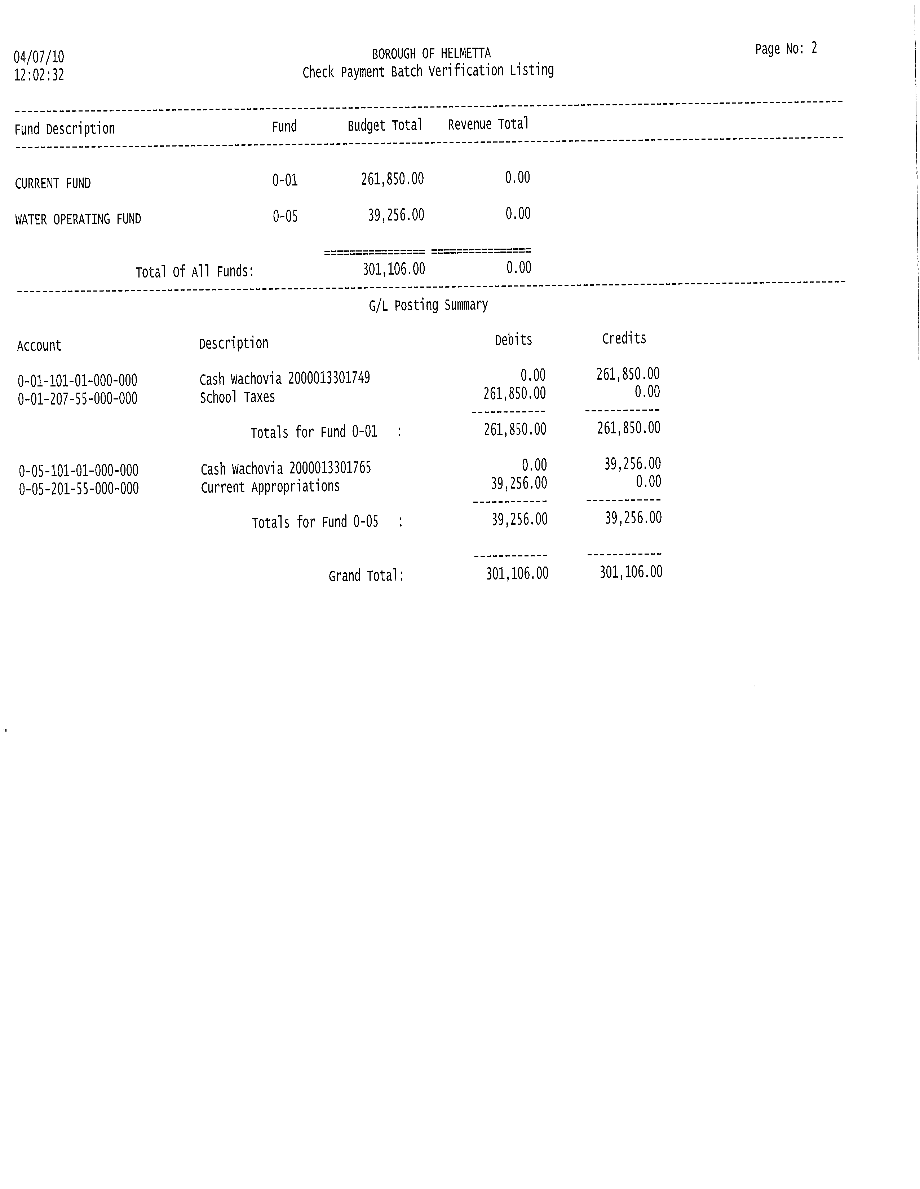

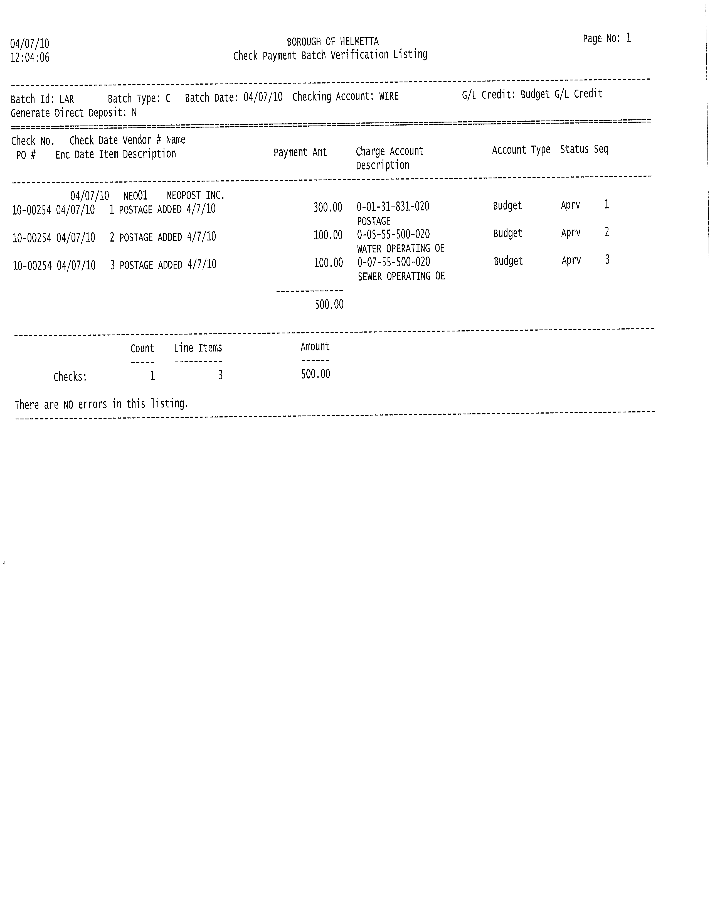

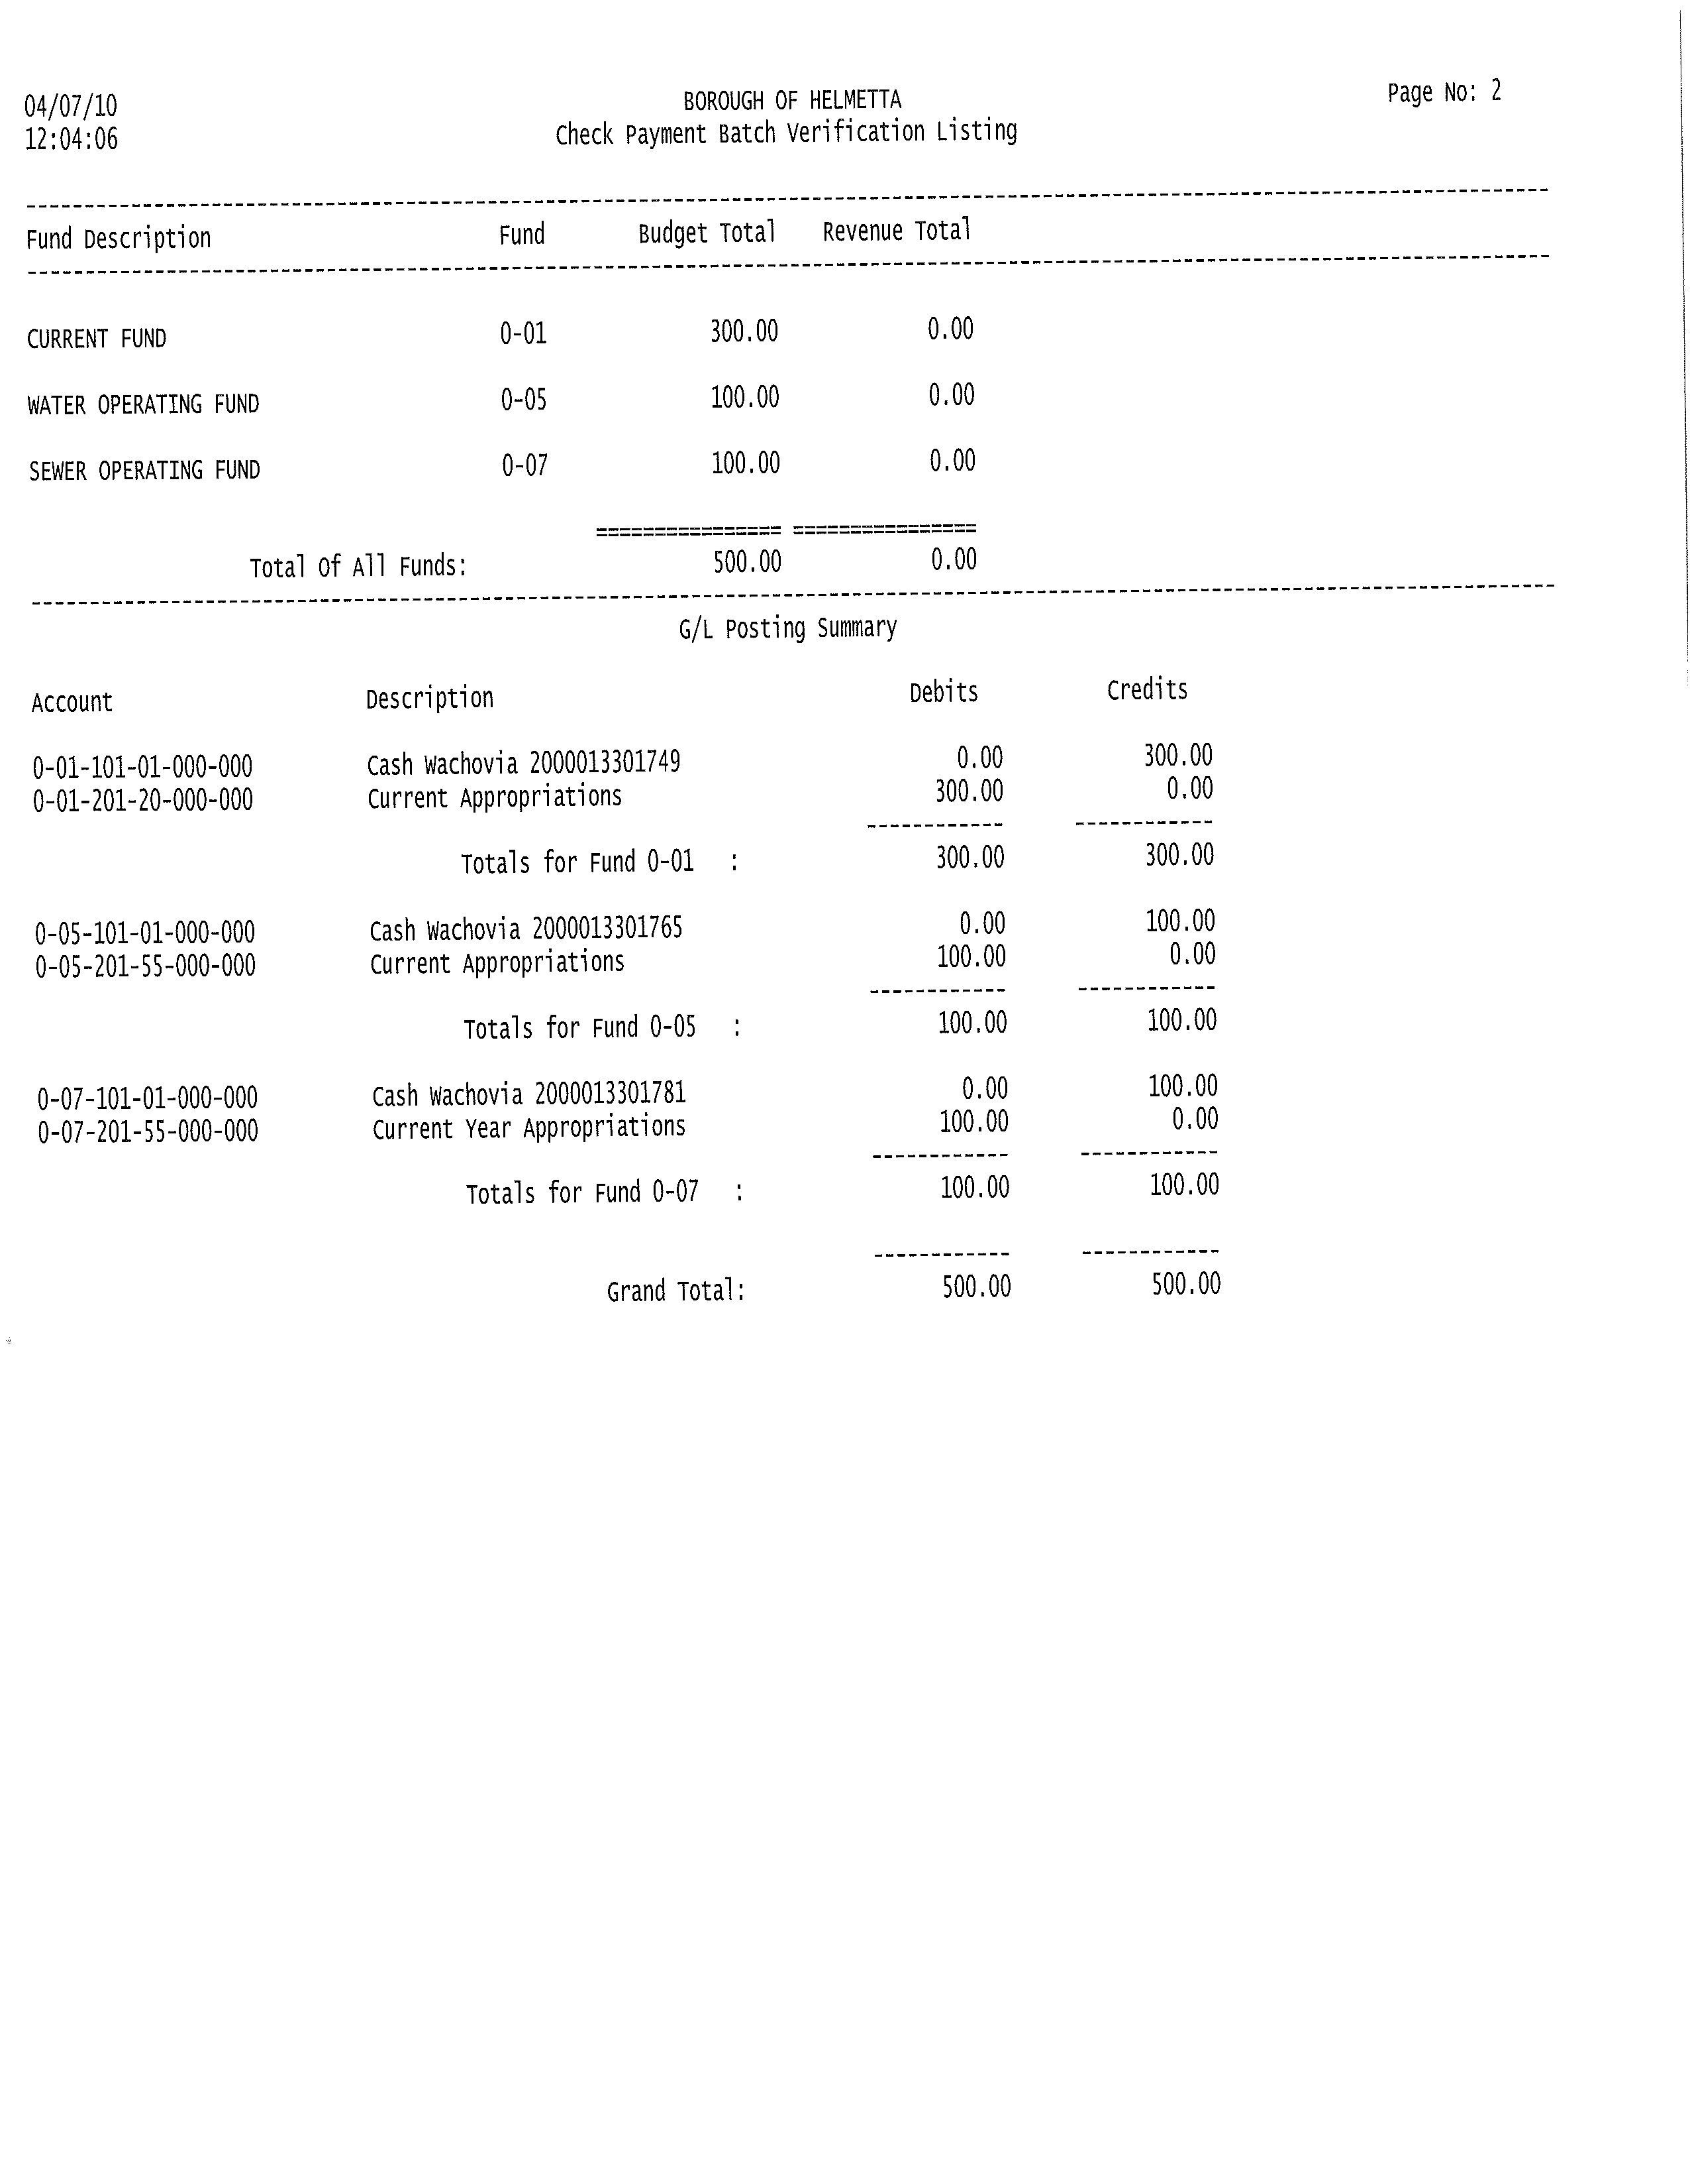

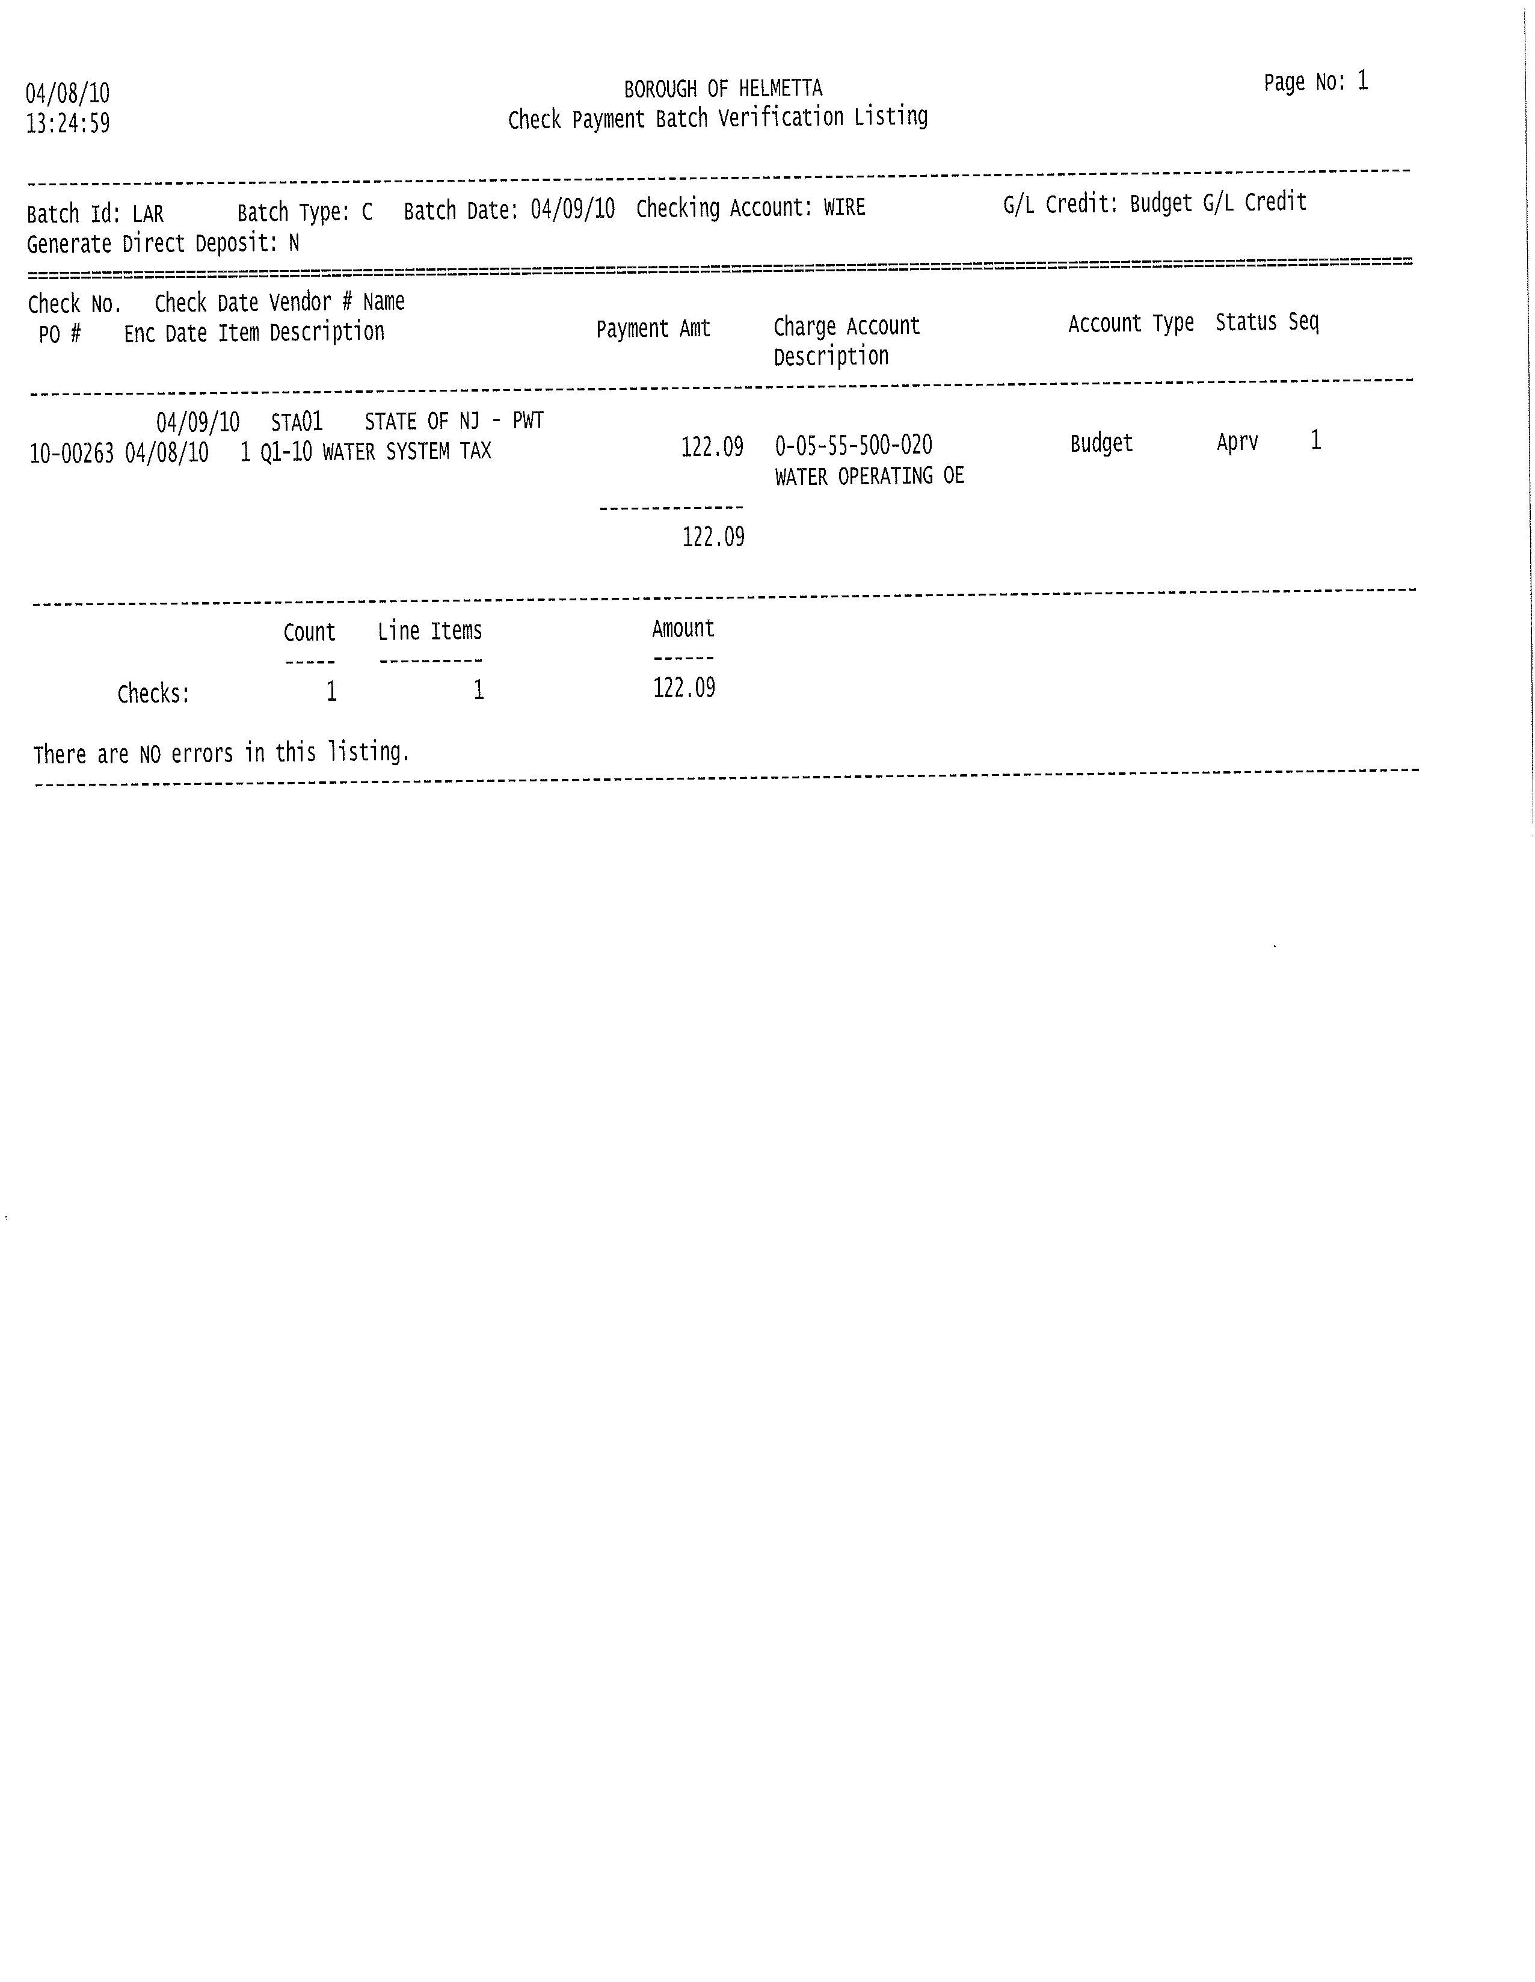

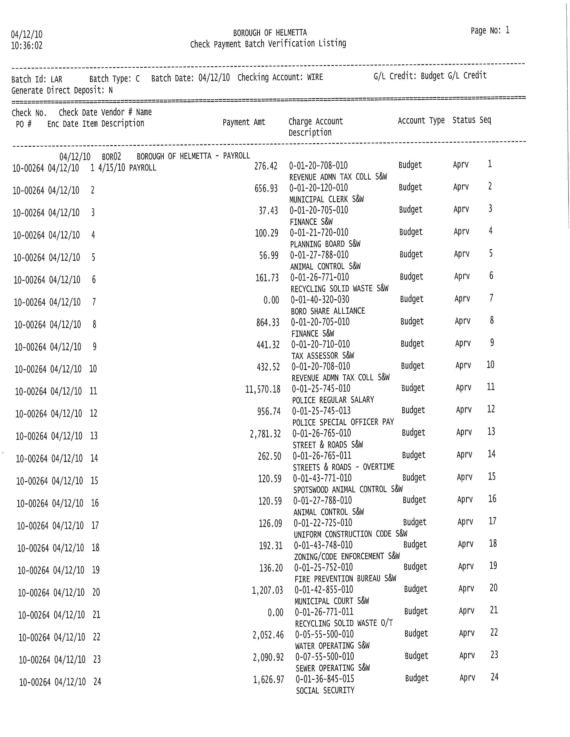

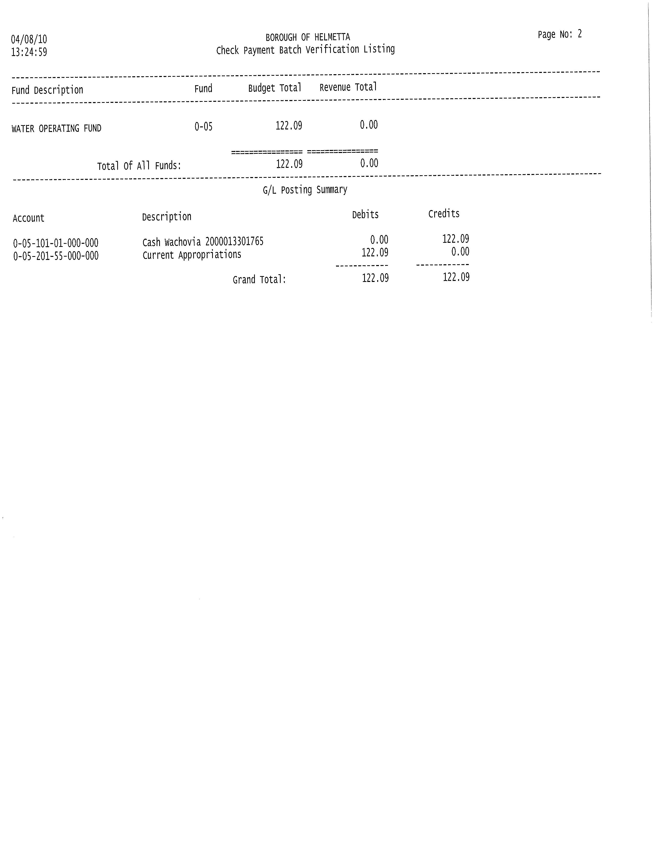

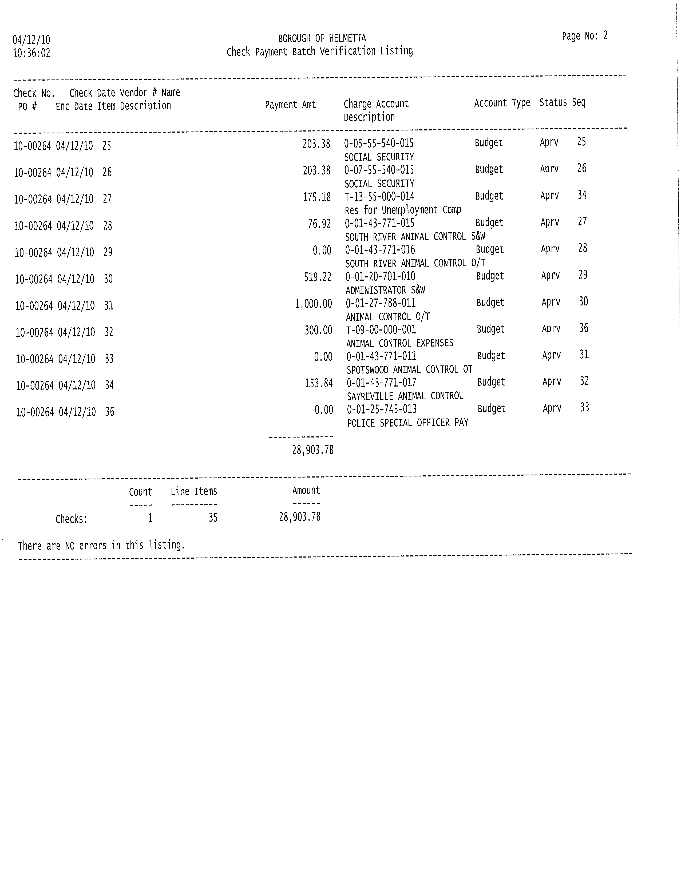

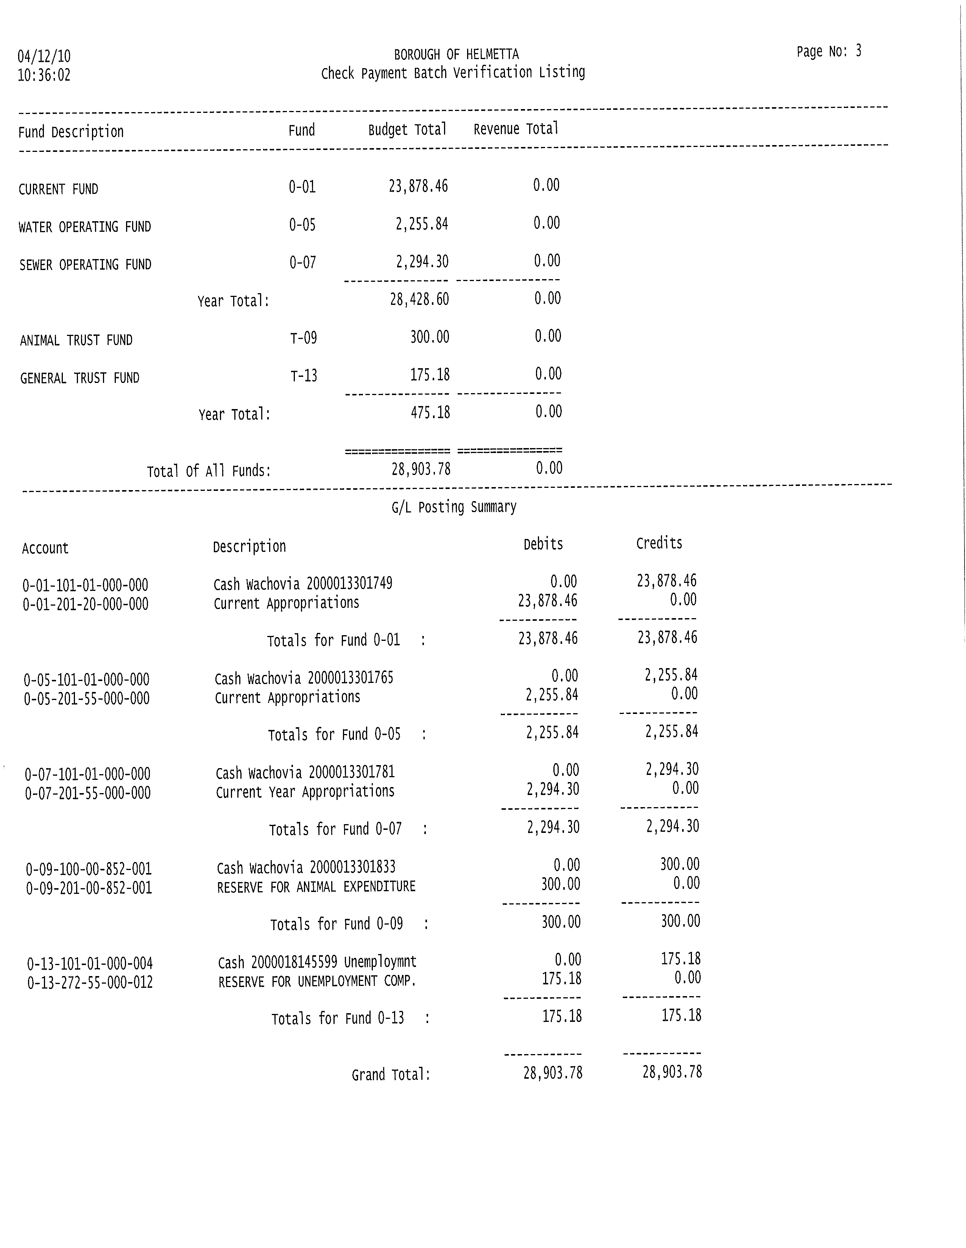

MOTION – Clmn. Asciolla SECOND – Clmn. Peckham
ROLL CALL: 4-0
The application for Peter Tresch was pulled to see if he already is a member of LOSAP.
Resolution # 2010 – 107 was pulled to include subject to the Borough Attorneys approval of maintenance bond.

RESOLUTION
# 2010-107
RESOLUTION AUTHORIZING FINAL PAYMENT TO MARIO'S CONCRETE & PAVING CO., INC. IN THE AMOUNT OF $31,520.98 FOR THE OLD FORGE ROAD RECONSTRUCTION PROJECT
WHEREAS, the Borough awarded a contract to Mario's Concrete & Paving Co., Inc. ("Mario's") for the Old Forge Reconstruction project (the "Project"); and
WHEREAS, the Borough Engineer has determined that all work has been completed in a workmanlike manner in accordance with the bid specifications for the Project; and
WHEREAS, a previous payment on October 26, 2009 was made in the amount of $139,564.74 and a change order was made on April 26, 2010 in the amount of$17,557.72; and
WHEREAS, the Borough Engineer has observed that stressed trees exist in the Project area and has advised Mario's that there may be a need for tree replacement in the future; and
WHEREAS, the Borough Engineer recommends final payment on the Project conditioned upon the posting of a maintenance bond in a form approved by the Borough Attorney and further conditioned upon the requirement that Mario's shall replace trees located on property within the Project area as required by the Borough Engineer during the term of maintenance bond; and
NOW THEREFORE BE IT RESOLVED by the Borough Council of the Borough of Helmetta that final payment to Mario's Concrete & Paving Co., Inc. is hereby authorized in the amount of $31,520.98 upon the posting of a ·maintenance bond in a form approved by the Borough Attorney and further conditioned upon the requirement that Mario's shall replace trees located on property within the Project area as required by the Borough Engineer during the term of maintenance bond

BE IT FURTHER RESOLVED, that the Chief Financial Officer has executed a certification of Funds for this contract, which is attached hereto, and that sufficient funds are available for said contract from Account Number C-04-55-500-610.
BE IT FURTHER RESOLVED that a certified copy of this Resolution shall be provided to each of the following:

- Mario’s Concrete & Paving, Co. Inc.
- Terry Vogt, Borough Engineer
- David A. Clark, Borough Attorney
- Lori Russo, CFO

MOTION – Clmn. Peckham SECOND – Clmn. Janeczek
ROLL CALL: 4 – 0

* REPORTS OF MAYOR, BOROUGH ATTORNEY, COMMITTEES, PUBLIC WORKS
The Mayor and Borough Attorney had no reports.
PUBLIC WORKS REPORT APRIL 28 2010
WATER INCREASE
- The Borough needs to set the summer water usage
- Previous number used was 255,000 GPD
- New number runs from May 1 to Oct 31 2010

COMMUNITY SERVICE
- Community service is requesting a change in hours
- New hours would be 7:45 to 3pm (l^{s}t,3rd,&5th sat)
- Brandon is willing to work those hours
- Brandon will accept comp time hour for hour for all Saturdays except the 3rd
- County reimburses Helmetta for paint day (3rd) sat.
- Request resolution be done to out line this G) If approved by council Union will be notified
H} Need to include resolution with collective bargaining contract
10 Erickson Ave.
- Sue Bishop would like to purchase Borough property adjacent to her house
- Request Council discuss
- If agreeable outline process to complete
HV AC PM CONTRACT
- Mack Industries has provided 2010 maintenance contract
- Cost is $1870.00
- Recommend the Borough renew

FIRST READING OF ORDINANCE
2010 – 11 AN ORDINANCE TO EXCEED THE MUNICIPAL BUDGET APPROPRIATION LIMITS AND TO ESTABLISH A CAP BANK (N.J.S.A. 40A:4-45.14) IN THE BOROUGH OF HELMETTA, COUNTY OF MIDDLESEX, STATE OF NEW JERSEY (complete ordinance at end)
MOTION – Clmn. Asciolla SECOND – Clmn. Janeczek
ROLL CALL: 4 - 0

* NEW BUSINESS
Animal control/shelter spreadsheet – there are at least 12 towns interested.
Property at 4 Main Street – Construction Department will inspect his property
Police Department renovations – work is desperately needed in that Department.
Tiling of hallway – we are looking into tiling the floors.
E-mail from Mr. Pokropinski – he wants us to send a letter to the Board of Education
Permit Parking only – the public is parking by the water tower.
Change in copy fees – fees must be changed from 75 cents a copy to 10 cents.
Fee charged for Police application – should we charge a fee for a police application.
Purchase of property by Mrs. Bishop – Public Works Director Darren Doran will look into this.
Helmetta Business Park wall – we have a survey of the wall.

* CLOSED SESSION - RESOLUTION # 108A Negotiations and litigations
MOTION – Clmn. Asciolla SECOND – Clmn. Janeczek
ROLL CALL: 4 - 0

*ADJOURNMENT
There being no further business, the meeting was adjourned at 8:40 p.m.

Sandra Bohinski, RMC
Sandra Boinski, RMC/CMR
Municipal Clerk

BOROUGH OF HELMETTA
ORDINANCE NO. 2010 - 11

AN ORDINANCE TO EXCEED THE MUNICIPAL BUDGET APPROPRIATION LIMITS AND TO ESTABLISH A CAP BANK (N.J.S.A. 40A:4-45.14) IN THE BOROUGH OF HELMETTA, COUNTY OF MIDDLESEX, STATE OF NEW JERSEY

WHEREAS, the Local Government Cap Law (N.J.S.A. 40A:4-45.1 et seq.) provides that in the preparation of its annual budget, a municipality shall limit any increase in the budget to 2.5% unless authorized by ordinance to increase it to 3.5% over the previous year’s final appropriations, subject to certain exceptions; and

WHEREAS, N.J.S.A. 40:4-45.14a provides that a municipality may, when authorized by ordinance, appropriate the difference between the amount of its actual final appropriation and the 3.5% as an exception to its final appropriations in either of the next two succeeding years; and

WHEREAS, the Borough Council of the Borough of Helmetta in the County of Middlesex finds it advisable and necessary to increase its CY2010 budget by up to 3.5% over the previous year’s final appropriations, in the interest of promoting the health, safety and welfare of the residents; and

WHEREAS, the Borough Council of the Borough of Helmetta hereby determines that a 3.5% increase in the budget for CY2010 over CY2009, amounting to $13,904.37 in excess of the increase in final appropriations otherwise permitted by the Local Government Cap Law, is advisable and necessary; and

WHEREAS, the Borough Council of the Borough of Helmetta hereby determines that any amount authorized above not appropriated as part of the final budget shall be retained as an exception to final appropriation in either of the next two succeeding years.

NOW THEREFORE BE IT ORDAINED, by the Borough Council of the Borough of Helmetta, in the County of Middlesex and State of New Jersey, a majority of the full authorized membership of the Governing Body affirmatively concurring, that in the CY2010 budget year, the final appropriations of the Borough of Helmetta shall, in accordance with this Ordinance and N.J.S.A. 40A:4-45.14, be increased by 3.5% over the CY2009 final appropriations, amounting to $48,665.30, and the CY2010 municipal budget for the Borough of Helmetta be approved and adopted in accordance with this Ordinance; and

BE IT FURTHER ORDAINED that any amount authorized by this Ordinance that is not appropriated as part of the final CY2010 budget shall be retained as an exception to final appropriations in either of the next two succeeding years; and

BE IT FURTHER ORDAINED that a certified copy of this Ordinance as introduced be filed with the Director of the Division of Local Government Services within five (5) days of its introduction; and

BE IT FURTHER ORDAINED that a certified copy of this Ordinance upon adoption, with the recorded vote included thereon, be filed with the Director of the Division of Local Government Services within five (5) days of final adoption; and

BE IT FURTHER ORDAINED that if any part or parts of this Ordinance are for any reason held to be invalid, such adjudication shall not affect the validity of the remaining portions of this Ordinance; and

BE IT FURTHER ORDAINED that all ordinances or parts of ordinances inconsistent herewith are repealed, but only to the extent of such inconsistency; and

BE IT FURTHER ORDAINED that this Ordinance shall take effect immediately upon its adoption and publication as required by law.

